# Project 3 Requirement and Modeling

## Requirements

**Content**

*Providing a Multitude of stories and articles*

Users prefer to get their news from a variety of sources

Note: Local news, national news, newspapers, etc.

**Content**

*Type of News*

Users are interested in a variety of news topics

Note: Politics, science, entertainment, etc.

**Privacy**

*Privacy of User Accounts*

User accounts should be secured by a strong password, keeping information secure

**Account Creation**

*Customization*

User personalization allows for specific news feeds created for individual users

**Fact Checking**

*Providing accurate news*

Fact checking should be fast and easy for users

**Fact Checking**

*Political Bias*

Potential bias of news sources/authors should be noted

Note: Many users note political bias from their news sources

**Fact Checking**

*Source Listing*

The sources used in an article should be available to the user

**Subscription**

*Getting notifications*

Users want to be able to get notifications of news articles from selected genres.

**Search Feature**

*Searching for Interesting Stories*

Users want to search for news stories that interest them

Note: By keyword, subject, author, location, etc.

**Sharing**

*Social Media*

Many users find news and share news via social media

Note: Ability to share stories and links via Facebook, Twitter, etc.

**Content**

*Multiple Sources*

Topics should have articles from different sources to show variance between sources

**Access**

*Application*

Users should be able to download an application to get news straight to their phones

## User Models

**Users**: User, Editor, Submitter

**Sub-Roles**: subscribed-user/guest user,

**Mediated Roles**: Web Server, Software

User class for each role:  
**User, General**: Background – high variation of age, ethnicity, gender, and cultures assumed, low to medium computer experience assumed. Expected age group, 25-35; some outliers expected for older population that has grown comfortable with technology and younger population that gets interested in current events or topics of interests at an earlier age.

**Editor**: Background, high level computer experience required, multiple editors assumed, high diversity required, expected age group, any. Want mix of background experience in HCI, software development, software engineering, Q&A, actual news editing experience, etc. This way the most factually accurate news gets to the user.

**Submitter**: Background, news-oriented, low to medium computer experience assumed. Expected age group; any. High diversity in both the role and the field of news (i.e. expert in fitness or sports news, expert in political news, etc.)

**Subscribed-User**: Background, high variation, low level computer experience assumed. Expected age group, 25-35; some outliers for older population and younger population taking interest in technology and news expected. Note that this specialized user gets notification texts when a new article in one of their top three interests comes out and has been validated.

**Guest User**: See User, General for anticipated background, experience, etc. is the same save that the guest user does not have the option to receive text notifications about newest validated articles in their chosen interests.

**Web Server**: a server where news article files are added and/or removed based on validation processing and results. This process is optimized via batch jobs and batch tasks that will be enabled to ensure that throughput and overall execution time is handled, and task flow is executed properly so that optimization of the files are incorporated.

**Software**: Machine Learning/AI API platform; this pulls in the articles that are submitted, as well as web scraping for other articles to sort through and verify to choose the most factually correct. Then batches are delivered to the editors who are assigned users to filter articles to based on interest.

# Usage Model

## Task Interaction Models

Hierarchical Task Inventory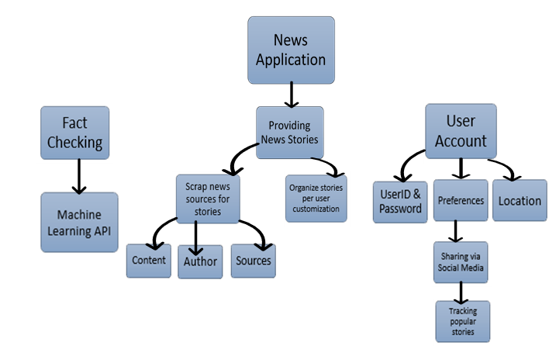

**Task Name**: Fact-checking articles for user

**Task Goal**: Take in multiple articles from multiple searches based on user input/search and returning the most factually accurate articles to the user.

**Task Trigger**: Once user picks areas of interest and searches for articles based on keywords and filters.

|  |  |
| --- | --- |
| User | App |
| 1. Finds, based on search and keywords, a series of articles on a given subject. | 2. The software then runs the articles submitted/web scraped and looks for if a news site is authentic  3. Checks keywords to see if article is opinion piece  4. Checks whether or not the article has reference links and/or a proper bibliography  5. Checks whether or not the author is a verified submitter for the news site  6. Checks whether or not the article is an opinion piece  7. Goes through the links/bibliography and fact checks them against various other articles and databases (like those for published research papers). |

**Barrier:** Author is a verified submitter for an official news site but is known for his/her bias in regard to politics

**Response to barrier:**

|  |  |
| --- | --- |
| 1. Flag the articles by this author for review for our editors so that their articles regarding politics are filtered out | 2. Return articles to the user that do not have this author’s articles in the results screen. |

**Task Name**: User shares the articles via social media

**Task Goal**: The user can choose multiple social media platforms (Facebook, Twitter, etc.) and share any articles they chose.

**Task Trigger**: The user taps the “Share” icon in the app.

|  |  |
| --- | --- |
| User | App |
| 1. Taps the “Share” Sendicon. | 2. A miniature pop-up window shows up with platforms greyed out  3. User choses platforms, such as Facebook, Twitter, Reddit, etc.  4. Upon choosing a platform, it becomes colored/no longer greyed out (Twitter icon becomes blue, f Facebook icon becomes blue, etc.)  5. Shares article across whichever platforms the user chooses |

**Barrier:** Sharing articles on image-based platforms such as Instagram would require the extra step of screenshotting the article one section at a time.

**Response to barrier:**

|  |  |
| --- | --- |
| 1. Have the option to convert the article into images slices such that all of the article is captured. | 2. Assemble the image slices into one image so user can share the article. |

**Task Name:** Finding appropriate articles for user

**Task Goal:** Helping user find and choose articles based on what they searched and what they wanted.

**Task Trigger:** User opens the app and finds news about something they want to know.

|  |  |
| --- | --- |
| User | App |
| 1. Click the search bar, and find the news that interest them (“rtx 2080 ti”) | 2. Show results about verified articles related to information (“rtx 2080 ti”) |

**Barrier:** Those articles does not have information that the user is looking for

**Response to barrier:**

|  |  |
| --- | --- |
|  | 1. Add a filter symbol (Image result for filter symbol) next to a search bar, so that when user press that symbol, it shows up another search bar. Add some option such as “AND”, “OR” to the second and after search bars. |
| 2. User enter another keywords “release date” | 3. Show results about verified articles related to information (“2080 ti” and “release date”) |

**Barrier:** User presses the filter button continuously.

**Response to barrier:**

|  |
| --- |
| 1. Limit to 10 search bar entries, and ask the user to input some keywords before the next search bar entry option shows up. |

**Barrier:** User’s search is incomplete or gibberish.

**Response to answer**

|  |  |
| --- | --- |
| 1. User input some keywords such as “vs rtx 5080” or “completely free” | 2. Show some related articles. When there aren’t any articles that match the keywords, show the notification saying that we cannot find the appropriate articles as well as show reset button (https://lh3.googleusercontent.com/oT_ihx0V8r7T5NJMgVm2eSOdeB5igIse0HYtx1NH7gAIr0-YJIv-x7MamMAtMOfvIR3kjbVBr0TMfq6Tm8XteMPvOcI1oTM3_RIOsHEuMrEGCpFX7JU5MOK630tHdbW4lYccEzMnocRwnplqDA) to reset and ask user input keywords again |
| 3. User reset and input keywords and search (“Pokemon Let’s go” and “switch”) | 4. Show verified articles relating to keywords (“Pokemon Let’s go” and “switch”) |

**Barrier:** There are some articles with lots of ads

**Response to barrier:**

|  |  |
| --- | --- |
|  | 1. Show a message saying that “Do you want to block ads, which increase your phone’s speed but block the writer from making money?” If the user press yes, then block; else do not block |
| 2. User press “Yes” button and then read news |  |

**Task Name:** Instruction for first-time user

**Task Goal:** Show what user use the app after downloading it from app store/google store

|  |  |
| --- | --- |
| User | App |
| 1. Open the app after downloading it | 2. Show 3 options: Sign-in, Sign-up, or Proceed without sign-in (not recommended) |
| 3. User pressed sign-up button | 4. Show list of questions ask user to input (Email, Password, Genres/Hobby (Optional), Telephone Number) |
| 5. User list all information and then press “Proceed” button |  |

**Barrier:** User input fake email or fake phone number

**Response to barrier:**

|  |  |
| --- | --- |
|  | 1. Access to some place to check if email or phone number is real or fake. If it is fake, then ask the user to input again. |
| 2. User input again and proceed successfully | 3. Ask user to use whether “2 factor authentication” or “back to log-in” with message “Use 2 factor authentication to protect your phone’s information” as well as introducing some cool features when user use “2 factor authentication” |
| 4. User press 2-factor authentication | 5. Send message to phone and ask user to input the code into the box. If User input right then proceed to log-in, else ask user to input again. |

## Barrier Summary

|  |  |  |  |
| --- | --- | --- | --- |
| Number | Trigger | Goal | Barrier |
| 1 | User interacts with web server | Process user’s input | Web server down |
| 2 | User creates an account to customize news experience | Username and Password must match to login | Username and / or password is incorrect |
| 3 | Editor looks through potential articles to post on site | Editor selects article to post | Article has been changed since going through software |
| 4 | Editor interacts with web server | Process editor’s input | Web server down |
| 5 | Submitter submits article to go through the software | Software runs article through code | URL has been changed |
| 6 | Software sends notification to Submitter | The submitter receives a notification | The submitter’s email is incorrect causing them to never receive the notification |
| 7 | Software needs to be kept up to date | Find problems in code | Software is under maintenance |